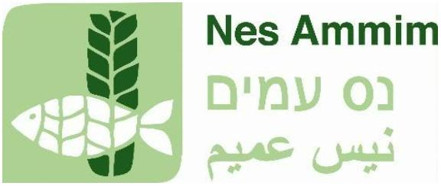

Nes Ammim is a village in the Western Galilee, Israel, dedicated to encounter and dialogue, learning, and hospitality. It is home to an international Christian community of volunteers that was founded in 1963 and is supported by European Christians and churches. Motivated by the lessons of the past and the challenges of the present, we live, work, and learn in solidarity with the diverse people of the region and the country—Jews, Muslims, Christians, Druze, and others.
Nes Ammim is currently seeking a
Head (M/F/D) of Technical Services
(in Nes Ammim, Israel)
Job description:
The village of Nes Ammim consists of approximately 75 residential units, a guesthouse with 48 rooms, and infrastructure that includes water, electricity, air conditioning, telephone, internet, and sewage systems. The Nes Ammim Technical Department is responsible for the overall maintenance and development of the village’s and guesthouse’s buildings, infrastructure, machinery, equipment, vehicles, and so on.
Tasks:
- Manage the technical department in collaboration with a local manager, including oversight of external contractors for major construction projects
- Lead a team of up to 5 volunteers, providing guidance and assigning tasks
- Perform daily maintenance and carry out repair work
- Plan the annual budget and ensure budget compliance
- Planning renovation and modernization measures
- Conducting problem analyses and developing solutions, including about energy conservation and renewable energy.
Requirements:
- Proven (professional) experience and in-depth knowledge in (preferably) all technical fields: electricity, maintenance of large air conditioning systems, water, wastewater, vehicle maintenance, woodworking, painting, welding, mechanics, and construction
- Good English skills (knowledge of Hebrew and Arabic is an advantage)
- Drivers License
- Experience working with people of all ages (especially young adults)
- “Hands-on” attitude, flexible (including regarding work hours), cooperative, creative, resourceful
- Full commitment to the mission, vision, and core Christian values of Nes Ammim
- Willingness to live in a small international Christian community for a period of preferably one year or longer.
We offer you:
- A varied, full-time volunteer position with responsibilities, in a beautiful setting
- Housing, meals, pocket money, use of a car, health insurance, and a minimum contribution to retirement fund
- The opportunity to participate in an interesting study program.

Questions?
Do you have any questions about Nes Ammim, the position, or the application process? If so, please contact Elena Sonnenberg via hrm@nesammim.com.
Application process:
Please send us your CV and a letter of application explaining why you are interested in this position, why you would like to join our movement, and what Nes Ammim means to you from the perspective of your Christian faith. Please send your application to Elena Sonnenberg at hrm@nesammim.com.
An (e-)assessment may be part of the process. Nes Ammim values equal opportunity and is committed to diversity in the workplace.

